
NOTE: This is an official document by Indexademics. Unless otherwise stated, this document may not be accredited to individuals or groups other than the club IDX, nor should this document be distributed, sold, or modified for personal use in any way.
IDX G9 CHEM H STUDY GUIDE ISSUE 8
By Hayley and Allison, Edited by Edward

Contents:
- 8.8 Bonding in Metals
- 8.9 Molecular Covalent and Covalent Network Structure
- 9.1 Molecular Shapes
- 9.2 The VSEPR Model
- 9.3 Molecular Shape and Polarity
- 9.4 Covalent Bonding and Orbital Overlap

8.8 Bonding in Metals
- Closely packed cations and loosely held valence electrons rather than neutral atoms
  - “Sea of electrons”
- Metallic bond: the attraction force between the free-floating valence electrons and cations
- Properties of metals
  - Good conductors of heat and electricity
    - Valence electrons have freedom to move, allowing them to conduct
  - Malleable and ductile
    - When force is applied to a metal, electrons shift and stay bonded
    - Ionic crystal: when force is applied, a layer of ions is shifted like charges repel shatters (not malleable/ductile)

8.9 Molecular Covalent and Covalent Network Structure
- Molecular covalent structure
  - Diversity of physical properties among molecular covalent compounds is mainly because of widely varying intermolecular attractions
  - In molecular covalent compounds, only weak intermolecular attractions need to be broken
  - Relatively low melting and boiling points compared to ionic compounds
  - Molecular covalent substance can be:
    - Solid (e.g., I₂)
    - Liquid (e.g., H₂O, C₂H₅OH, Br₂)
    - Gaseous (e.g., CO₂, O₂, N₂)
- Covalent network structure
  - Most stable substances are network solids (or network crystals), solids in which all atoms are covalently bonded to each other, e.g.:
  - Diamond
    - Each carbon atom is covalently bonded to four other carbons
    - Interconnected tetrahedral structure stable
    - Vaporizes (~3500℃) instead of melting
    - Uses: tips of drills, metal coat
  - Graphite
    - Carbon atoms arranged in layers held together with weak attractive forces
    - Properties: soft, conductor of electricity
    - Higher melting point than diamond
    - Uses: lead core in pencil, lubricant, electrode in batteries
  - Quartz
    - Silicon dioxide
    - Giant covalent structure similar to diamond
    - Each silicon atom is bonded to four oxygen atoms, and each oxygen atom is bonded to two silicon atoms

9.1 Molecular Shapes
- Different models for representing molecular shape
  - Ball and stick
  - Space-filling
  - Lewis structure
  - etc.
- Number of bonding & nonbonding electrons determines the shape of the molecule
  - Plays an important role in the molecule’s properties

9.2 The VSEPR Model

VSEPR Theory
- Valence-shell-electron-repulsion-theory (VSEPR Theory) explains the 3D shape of molecules
  - It states that: the repulsion between electron pairs causes molecular shapes to adjust so that the valence-electron pairs stay as far apart as possible
- Shared pair: a bond between two atoms is considered as one shared pair, regardless of the number of electrons which are actually shared
- Nonbonding (lone) pair: lone pair of electrons
- Bond angle: the angle between two adjacent bonds
  - Lone pair exerts greater repulsion force than shared pair decreases bond angles
  - Double/triple bonds place greater electron density on one side of the central atoms compared to single bonds affects bond angle
- Electron pairs are referred to as electron domains
  - In a double/triple bond, all electrons shared between those two atoms are on the same side of the central atom considered as one electron domain
- For larger molecules, geometry of a particular atom is discussed instead of the molecule as a whole

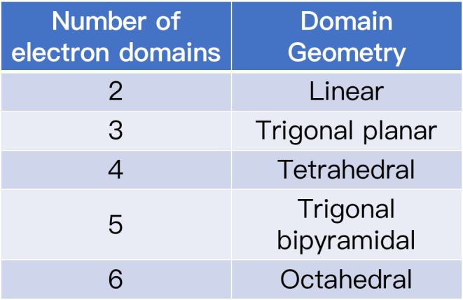
Domain Geometry

Molecular Shape
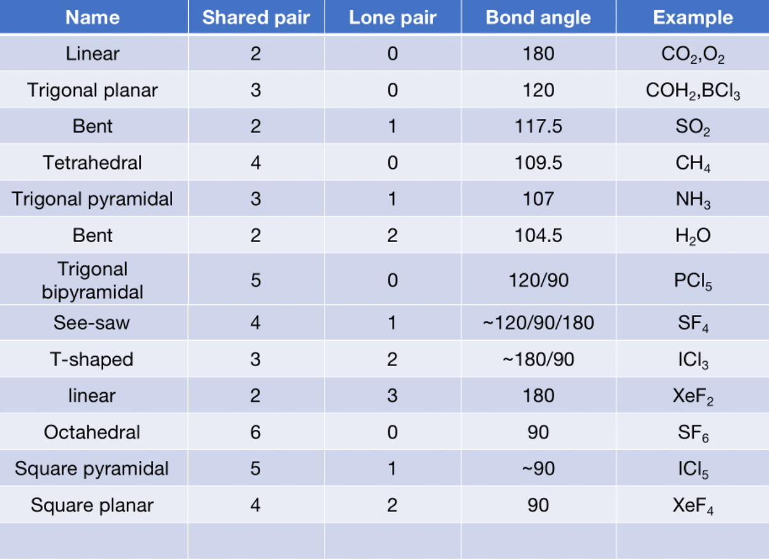

9.3 Molecular Shape and Molecular Polarity
- Polar molecule (dipole): a molecule with one positively charged end and one negatively charged end
- Nonpolar molecule: a molecular without positive or negative ends
- If the molecular shape is symmetrical, then it is nonpolar (e.g., CO₂)
- A polar molecule must have
  - An asymmetrical structure and
  - Bond polarities that do not cancel with each other
  - e.g., H₂O

Predict whether the following molecules are polar or nonpolar: BrCl, SO2, SF6
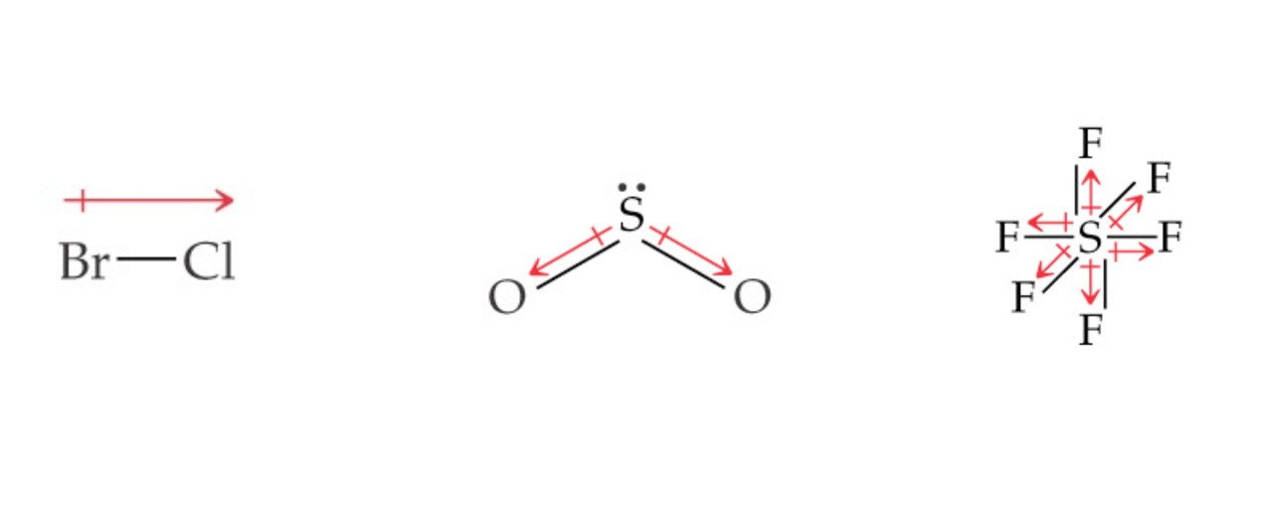

9.4 Covalent Bonding and Orbital Overlap
- Covalent bonds form through sharing of electrons by adjacent atoms
  - Therefore orbitals of the two atoms must overlap
- Increased overlap brings the electrons and nuclei together while simultaneously decreasing electron-electron repulsion
  - If atoms get too close, the internuclear repulsion greatly raises the energy
